Fire and Smoke Detection using Deep Learning Models

Project progress report submitted to
MANIPAL ACADEMY OF HIGHER EDUCATION

For Partial Fulfillment of the Requirement for the Award of the Degree
of
Bachelor of Technology
in
Computer Science and Technology
by
Chintakunta Guru Dinesh Reddy
Reg. No. 220905438
Under the guidance of

Dr. Sucharitha Shetty
Associate Professor
School of Computer Engineering Manipal Institute of Technology Manipal, India


March 2026

Introduction
Fire accidents are one of the major causes of damage to life and property across the world. Fires can occur in forests, industries, residential buildings, and public places. If fire or smoke is detected at an early stage, it becomes easier to prevent large disasters and reduce losses.
Traditional fire detection systems are mostly based on sensors such as smoke detectors, temperature sensors, and flame sensors. These systems work well in small indoor environments but they may not perform effectively in large open areas. For example, in forests or large industrial spaces, smoke sensors may take longer to detect fire or may fail due to environmental conditions.
With the development of artificial intelligence and computer vision, deep learning techniques can be used to detect fire and smoke directly from images and video streams. These systems analyze visual information and automatically recognize patterns related to fire or smoke.
Object detection models are widely used in computer vision tasks. One of the most popular object detection models is YOLO (You Only Look Once). YOLO models are known for their fast processing speed and good detection accuracy. They are widely used in real-time applications such as surveillance systems, traffic monitoring, and safety systems.
In this project, a fire and smoke detection system is developed using different versions of YOLO models. The models used in this study include YOLOv8, YOLOv9, YOLOv10, and YOLOv11. The objective of this work is to train these models on a fire and smoke dataset and compare their performance using evaluation metrics such as precision, recall, and mean average precision (mAP).
The trained models can detect fire and smoke in images and videos by drawing bounding boxes around the detected objects. This system can help in early fire detection and can be useful for monitoring environments such as forests, buildings, and industrial areas.

Literature Survey
Several studies have been conducted in the field of fire and smoke detection using computer vision and deep learning techniques. Earlier fire detection systems mainly relied on sensor-based methods such as smoke detectors, temperature sensors, and flame sensors. These systems are commonly used in buildings and indoor environments to detect fire incidents. Although these systems are useful, they have some limitations. They may not work effectively in large open areas or outdoor environments. In addition, sensor-based systems cannot visually detect fire from a distance or identify the exact location of fire in an image.
With the advancement of image processing and deep learning, computer vision techniques have been widely used for fire and smoke detection. Convolutional Neural Networks (CNNs) are commonly used for image classification tasks where the model learns patterns from images and predicts whether fire or smoke is present. CNN models can successfully identify fire-related features such as color, texture, and shape. However, CNN-based models mainly perform classification and cannot accurately determine the exact position of fire or smoke within an image.
To overcome this limitation, object detection models such as YOLO (You Only Look Once) have been introduced. YOLO models can detect objects and also locate them using bounding boxes in real time. Over the years, several improved versions of YOLO have been developed, including YOLOv8, YOLOv9, YOLOv10, and YOLOv11. These models provide better detection accuracy and faster processing speed. YOLO-based models have been successfully used in many applications such as forest fire monitoring, industrial safety systems, and surveillance systems. In this project, multiple YOLO models are trained and compared to determine the most suitable model for fire and smoke detection.

Problem Definition
Fire accidents can cause serious damage to human life, buildings, forests, and industrial environments. Early detection of fire and smoke is essential to prevent disasters and minimize damage.
Traditional fire detection systems rely on physical sensors that detect smoke or heat. These systems may fail in large open areas or outdoor environments where smoke spreads slowly or where environmental factors affect sensor readings.
Another challenge is that many systems cannot visually monitor large areas using cameras. Therefore, there is a need for an intelligent system that can automatically detect fire and smoke from images and video streams.
The main problem addressed in this project is to develop a computer vision based system that can automatically detect fire and smoke using deep learning models.
The system should be able to analyze images or video frames and identify fire or smoke accurately. In addition, the system should perform detection in real time and provide reliable results.

Objective
The main objectives of this project are:
- To study different deep learning models for object detection.
- To collect and prepare a dataset containing fire and smoke images.
- To train YOLO models for fire and smoke detection.
- To compare the performance of YOLOv8, YOLOv9, YOLOv10, and YOLOv11.
- To evaluate the models using performance metrics such as precision, recall, and mAP.
- To identify the best model for detecting fire and smoke.

Methodology

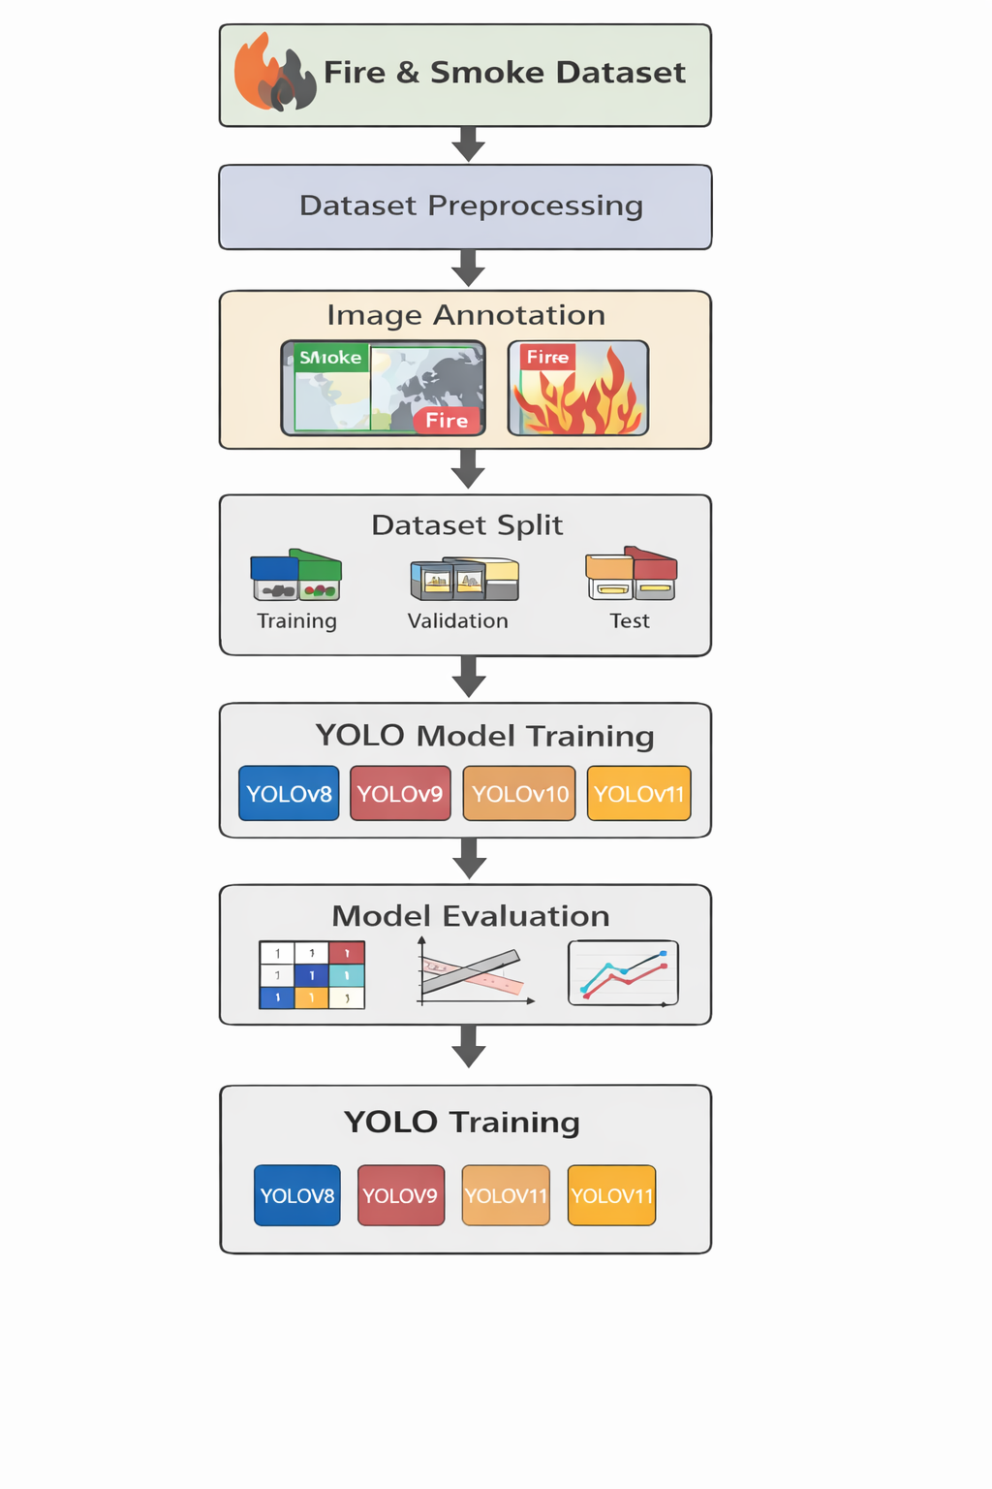
The figure shows the working process of the fire and smoke detection system. First, a dataset containing fire and smoke images is collected. The dataset is then preprocessed and annotated to mark fire and smoke objects. After annotation, the dataset is divided into training, validation, and test sets. Different YOLO models such as YOLOv8, YOLOv9, YOLOv10, and YOLOv11 are trained using the dataset. Finally, the models are evaluated using performance metrics like precision, recall, and mAP. In future work, fire type classification will be performed using HSV color analysis.

Data Collection
- The dataset used in this project contains images of fire and smoke collected from publicly available sources.
- The images represent different fire situations such as forest fires, building fires, and smoke in different environments.
- The dataset contains two classes:
1. Fire
2. Smoke
- These images are used to train and test the detection models.

Dataset Preprocessing
- The collected images may have different sizes and formats, so preprocessing is required.
- The preprocessing steps include:
- Removing damaged or duplicate images.
- Organizing images into proper folders.
- Organizing images into proper folders.
- This step helps prepare the dataset for model training.

Image Annotation
- To train the detection model, each image must be labeled.
- Bounding boxes are used to mark the location of fire and smoke in the images.
- The classes used in this project are:
- 0 – Smoke
- 1 – Fire
- These labels help the model learn how to detect fire and smoke..

Data Split
- The dataset is divided into three parts:
- Training dataset – used to train the model
- Validation dataset – used to check model performance during training
- Test dataset – used to evaluate the final model
- This helps improve the reliability of the model.

YOLO Model Training
- In this project, several YOLO models are used for fire and smoke detection.
- The models include:
- YOLOv8
- YOLOv9
- YOLOv10
- YOLOv11
- These models are trained using the prepared dataset.
- During training, the model learns the patterns of fire and smoke from the images.

Model Evaluation
- After training, the models are evaluated using performance metrics
- The models include:
- Precision
- Recall
- Mean Average Precision (mAP)
- These metrics help measure how well the model detects fire and smoke.
- The results of different YOLO models are compared to find the best performing model.

Workdone So Far
A dataset containing fire and smoke images was collected from publicly available sources. The dataset was organized into training, validation, and testing folders.
The images were labeled using bounding boxes to indicate the location of fire and smoke objects.
After preparing the dataset, multiple YOLO models were trained using the dataset. The models trained in this project include YOLOv8, YOLOv9, YOLOv10, and YOLOv11.
The results obtained from the experiments are summarized below

Model | Precision | Recall | mAP50
YOLOv8 | 0.755 | 0.718 | 0.767
YOLOv9 | 0.765 | 0.704 | 0.763
YOLOv10 | 0.733 | 0.663 | 0.725
YOLOv11 | 0.750 | 0.675 | 0.744
From the results, YOLOv8 achieved the best overall performance among the models tested.
The trained models were also tested using sample images and videos to verify that the system can correctly detect fire and smoke.

Remaining Work
Although the current system can successfully detect fire and smoke using YOLO object detection models, further improvements can be made to enhance the functionality of the system. One of the important future improvements is the classification of different types of fire. Fire can occur due to different materials such as wood, liquids, electrical equipment, or cooking oils. Identifying the type of fire is useful because different types of fire require different methods for extinguishing.
In this project, fire classification will be performed using the HSV (Hue, Saturation, Value) color space. HSV color space is widely used in image processing because it represents colors in a way that is closer to human visual perception. Fire usually contains strong red, orange, and yellow color components. By analyzing these color ranges using HSV values, it is possible to identify the characteristics of fire regions detected in the image.
Once the YOLO model detects fire in an image or video frame, the detected region can be further analyzed using HSV color analysis. Based on the color patterns and intensity values, the system can classify fire into different categories such as Class A (ordinary combustibles), Class B (flammable liquids), Class C (electrical equipment), Class D (combustible metals), and Class K (commercial cooking oils). This classification can help provide additional information about the type of fire and suggest appropriate fire safety measures.
In the future, this classification module can be integrated with the existing fire detection system. By combining object detection and fire classification, the system will not only detect fire and smoke but also identify the type of fire. This can make the system more useful for real-time monitoring applications in forests, industries, buildings, and public safety systems.

Scope
The proposed system demonstrates how wearable physiological sensors combined with machine learning techniques can be used to analyze cognitive states. Such systems have potential applications in many real-world domains.
In educational environments, cognitive state monitoring can help analyze student attention and mental workload during learning activities. In healthcare, physiological monitoring can assist in detecting stress and mental fatigue. In human-computer interaction, adaptive systems can adjust their behavior based on the user’s cognitive state.
Thus, this project contributes to the growing field of wearable computing and cognitive computing by exploring the use of physiological signals for cognitive state analysis.

References
[1] J. Redmon, S. Divvala, R. Girshick, and A. Farhadi, “You Only Look Once: Unified, Real-Time Object Detection,” Proceedings of the IEEE Conference on Computer Vision and Pattern Recognition (CVPR), 2016.
[2] Z. Ge, S. Liu, F. Wang, Z. Li, and J. Sun, “YOLOX: Exceeding YOLO Series in 2021,” arXiv preprint arXiv:2107.08430, 2021.
[3] C. Wang, A. Bochkovskiy, and H. Liao, “YOLOv7: Trainable Bag-of-Freebies Sets New State-of-the-Art for Real-Time Object Detectors,” arXiv preprint arXiv:2207.02696, 2022.
[4] T. Wang et al., “YOLOv9: Learning What You Want to Learn Using Programmable Gradient Information,” arXiv preprint, 2024.
[5] S. Frizzi, R. Kaabi, M. Bouchouicha, and J. Ginoux, “Convolutional Neural Network for Video Fire and Smoke Detection,” IEEE Conference on Industrial Electronics and Applications, 2016.
[6] P. Barmpoutis, K. Dimitropoulos, N. Grammalidis, “Fire Detection from Images using Faster R-CNN and Deep Learning,” International Conference on Engineering Applications of Neural Networks, 2019.
[7] S. Muhammad, A. Ullah, and S. W. Baik, “Vision-Based Fire Detection System Using Deep Learning,” IEEE Access, 2018.
[8] J. Schmidhuber, “Deep Learning in Neural Networks: An Overview,” Neural Networks, 2015.
[9] R. Gonzalez and R. Woods, “Digital Image Processing,” Pearson Education, 2018.
[10] A. Krizhevsky, I. Sutskever, and G. E. Hinton, “ImageNet Classification with Deep Convolutional Neural Networks,” Advances in Neural Information Processing Systems (NeurIPS),2012.

